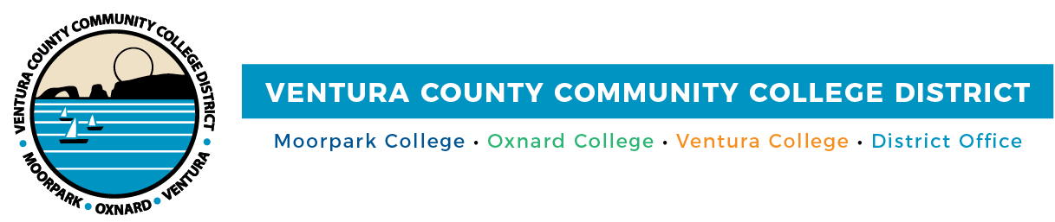

FOR IMMEDIATE RELEASE

VCCCD and TK-12 Leaders Unite to Expand Dual Enrollment Opportunities
Over 7,000 High School Students Have Accessed College Courses This Academic Year

Camarillo, Calif. (March 12, 2025) — The Ventura County Community College District (VCCCD) and the Ventura County Office of Education (VCOE) co-hosted their fourth Community of Practice on March 7. Held at Oxnard College, the event brought together TK-12 and community college leaders to discuss dual enrollment opportunities. With 7,000 local high school students already benefiting from dual enrollment this year, discussions focused on expanding access and creating seamless transitions from high school to college and careers.
A key topic of the Community of Practice was engaging students who may not yet see themselves as college-bound by offering structured dual enrollment opportunities.
“When we provide meaningful dual enrollment pathways for students who feel disconnected from high school, we increase their chances of staying engaged, graduating, and pursuing higher education,” said Rick MacLennan, VCCCD Chancellor. "These opportunities not only build confidence and foster hope but also empower students to see—and seize—the possibilities ahead of them.”
One of the most effective strategies discussed involves offering essential college courses — such as English, Math, and college-readiness — directly on high school campus during the regular bell schedule. This model is especially impactful for first-generation-to-college and lower income students, who are often underrepresented in higher education. By reducing barriers, these programs help students earn both college and high school credit, keeping them on track for timely degree completion.
“Helping students access college courses early is a powerful way to build their confidence and open new doors,” said Gabriela Torres, chair of the VCCCD Board of Trustees. "Expanding dual enrollment is about making sure every student has the chance to succeed.”
The Community of Practice also highlighted the importance of comprehensive support services, including IEP/504 accommodations, academic tutoring, and college readiness courses, to help students navigate higher education and improve retention and success rates.
To learn more about dual enrollment opportunities or how to enroll in college courses offered at your high school, contact your school counselor or visit vcccd.edu/dual-enrollment.
About Ventura County Community College District
The Ventura County Community College District is a member of the 116-campus California Community College system and serves approximately 30,000 students annually. The District's three colleges—Moorpark, Oxnard and Ventura—offer programs in general education for degrees and certificates, transfer to four-year colleges and universities, career technical education and provide opportunities to engage in co-curricular campus activities. For more information, visit vcccd.edu.

Media Contact:
Outreach and Marketing
Ventura County Community College District
communications@vcccd.edu

