**FOR IMMEDIATE RELEASE**

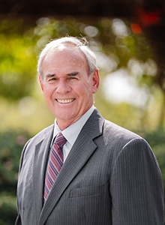 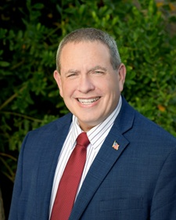  
Stan Mantooth Joe Piechowski

**VCCCD Installs New Trustee and Elects Board Leadership***Trustees welcome newly elected Joe Piechowski*

**Camarillo, Calif.** (Feb. 4, 2025) — The Ventura County Community College District (VCCCD) welcomed newly elected Trustee Joe Piechowski to the Board of Trustees during the Annual Organizational Meeting on December 17. Piechowski was installed with Trustee Stan Mantooth, who was re-elected in November.

At the meeting, Trustee Gabriela Torres, who has served on the board since 2018, was elected board chair. Trustee Lou Lichtl was elected vice chair, and Chancellor Rick MacLennan will serve as secretary.

"I am honored to have been elected Board Chair and look forward to working with my fellow trustees, and district leadership to foster an inclusive and equitable environment where all students can thrive. Our district’s success depends on ensuring every student has the support and opportunities they need, and I am committed to strengthening our engagement with the community to achieve that goal," said Torres, who is serving her first term as chair.

The five-member board of trustees, which also includes Trustee Joshua Chancer, works collaboratively to adopt policies that oversee all activities relating to the business of the District and its three colleges—Moorpark, Oxnard and Ventura Colleges. Student Trustee Sierra Whalen advocates on behalf of VCCCD students.  
Ventura County voters elect trustees in even-numbered years to four-year terms. The student trustee is elected annually through a district-wide student election.

Piechowski is the Area 4 representative, which encompasses Moorpark, Simi Valley, Santa Susana Knolls, Box Canyon, Bell Canyon, Chatsworth Peak, Home Acres, Sinaloa Lake and Tierra Rejada Valley.

As a resident of Simi Valley, Piechowski brings his previous experiences serving the community through the Simi Valley Neighborhood Council #4 and as a commissioner to the Area Housing Authority of the County of Ventura.

Mantooth will continue to represent Area 3, which includes portions of Camarillo, Port Hueneme, Santa Paula, Fillmore, Nyeland Acres, Oxnard College, Piru, Somis, Del Norte Area, Las Posas Valley and portions of Oxnard. He brings with him 45 years of experience in K–12 school districts and the County Office of Education and four years of service as a trustee.

“The Ventura County Community College District is committed to fostering student success and community engagement,” said Chancellor Rick MacLennan. “With the installation of Trustee Piechowski and the election of new board leadership, we look forward to continued collaboration in advancing opportunities for students at Moorpark, Oxnard, and Ventura colleges.”

The next board of trustees meeting is February 18, 2025, at the Ventura County Community College District Administrative Center and live-streamed by Zoom. Detailed information regarding board meetings is available at [vcccd.edu/board-of-trustees](http://www.vcccd.edu/board-of-trustees).

**About Ventura County Community College District***The Ventura County Community College District is a member of the 116-campus California Community College system and serves approximately 30,000 students annually. The District's three colleges—Moorpark, Oxnard and Ventura—offer programs in general education for degrees and certificates, transfer to four-year colleges and universities, career technical education and provide opportunities to engage in co-curricular campus activities. For more information, visit vcccd.edu.*