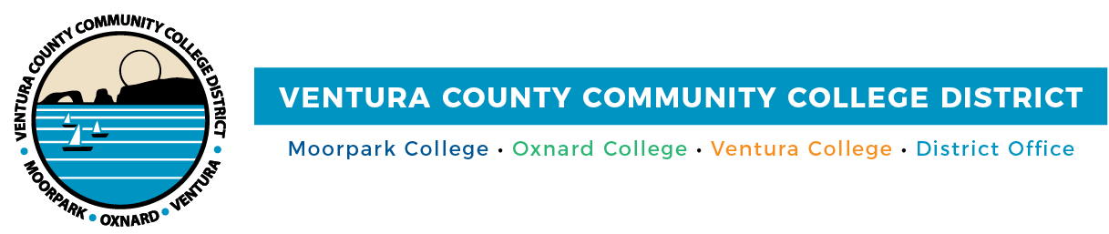

**FOR IMMEDIATE RELEASE**

[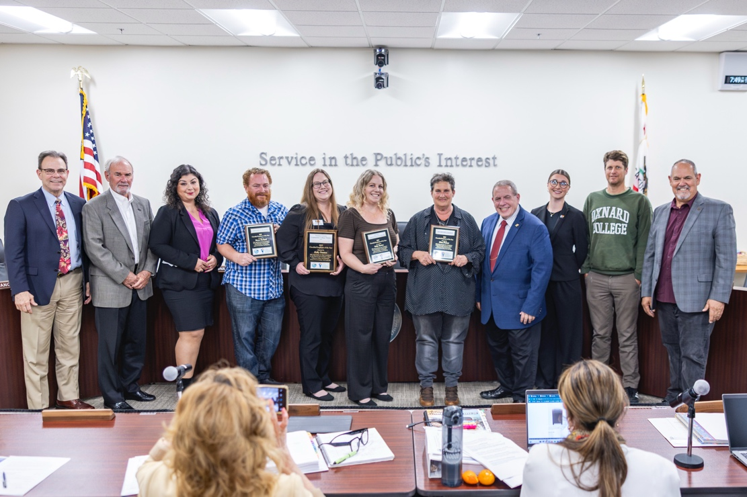](https://vcccd.mediavalet.com/portals/branded-portal_moorparkcollege)

**Classified Employees of the Year Honored Across VCCCD***Ventura College Honoree to be Considered for Statewide Award*

**Camarillo, Calif.** (April 11, 2025) — The Community Colleges of Ventura County proudly recognize Kelly Denton, Academic Data Specialist at Ventura College, as the 2025 Classified Employee of the Year. The annual award celebrates the excellence, professionalism and dedication of classified professionals who make an exceptional impact across our campuses and communities.

“This is our chance to recognize the incredible work Kelly Denton has done and how deeply she is valued by the Ventura College community,” said Board Chair Gabriella Torres. “Kelly was selected because of the meaningful impact she makes every day — through her dedication, leadership and the way she goes above and beyond to support students, faculty and staff alike.”

The Ventura County Community College District (VCCCD) awards the Classified Employee of the Year distinction in accordance with the California Community Colleges (CCC) Board of Governors, which will consider Denton for the CCC statewide award. At the May 2025 Board of Governors meeting, up to five recipients will be named California Community Colleges Classified Employee of the Year. Winners receive a $750 cash award and a plaque.

Additional Classified Employee of the Year nominees included Kelly Barton, Human Resources Assistant at the District Administrative Center; Dina Pielaet, Marketing, Communications, and Web Design Coordinator at Moorpark College; and Bryan Burland, Instructional Lab Technician II – Sciences at Oxnard College.

**“These incredible individuals represent the very heart of our colleges,”** said Chancellor RickMacLennan. **“They often work behind the scenes, but their impact is felt in every corner of our campuses. With every task, every interaction, they bring care, skill and a sense of purpose that uplifts our entire community. Our classified professionals are the driving force behind many of our accomplishments, and** we are deeply grateful for everything they do.”

**About the Honorees**

**Kelly Barton** exemplifies the principles of Vision 2030 through her dedication to equity, accessibility and community support as an HR assistant. Her efforts in recruiting a diverse field workforce directly impact student success by ensuring quality educators and staff. With professionalism, attention to detail and an equity-minded approach, she streamlines hiring while upholding transparency and fairness. Beyond HR, Barton actively contributes to districtwide initiatives, job fairs and community engagement, including disaster relief and small business advocacy. Her commitment to excellence and collaboration makes her a driving force for equitable student outcomes. And of all these attributes, Kelly is kind, dedicated and warm with an unwavering positivity that is contagious. She treats every task, big or small, with pride and dedication and every person, regardless of title or role, with respect and compassion.

**Dina Pielaet** demonstrates a deep commitment to equitable student outcomes through her leadership in marketing and communication at Moorpark College. She promotes baccalaureate attainment, supports student success initiatives and ensures clear, inclusive communication for students, faculty and staff. Beyond her role, she actively champions diversity, equity and inclusion through cultural events, LGBTQIA+ initiatives, and governance committees. A mentor to colleagues and student employees, Pielaet fosters a collaborative work environment while advocating for education and social impact through statewide organizations, union leadership and community service.

**Bryan Burland** is dedicated to equitable student outcomes and fostering student growth. As a key figure in the math and science division, he manages over 20 labs and recently stepped up to oversee chemistry and physical science during a staffing vacancy. His leadership, professionalism, and willingness to support colleagues ensure high standards across the division. Beyond his role, Burland played a vital part in the Marine Center relocation and actively volunteers at campus events to promote science education. His commitment to excellence, teamwork and service makes him a standout candidate for the 2025 Classified Employee of the Year.

**Kelly Denton** is a vital force at Ventura College, ensuring accurate course schedules, faculty assignments, and student planning systems as an academic data specialist. Her work directly supports equitable student outcomes, particularly in career education programs like nursing, paramedics, EMT and police science. Denton’s expertise and attention to detail make her a trusted resource, and her quick action has prevented disruptions affecting hundreds of students. Beyond campus, she contributes to districtwide and statewide initiatives, shaping curriculum and scheduling improvements. A problem-solver and leader, Denton’s behind-the-scenes efforts are essential to student and institutional success.

**About Ventura County Community College District**

*The Ventura County Community College District is a member of the 116-campus California Community College system and serves approximately 30,000 students annually. The District's three colleges—Moorpark, Oxnard and Ventura—offer programs in general education for degrees and certificates, transfer to four-year colleges and universities, career technical education and provide opportunities to engage in co-curricular campus activities. For more information, visit* [*vcccd.edu*](http://www.vcccd.edu)*.*

**Media Contact:**

Outreach and Marketing

Ventura County Community College District

[communications@vcccd.edu](mailto:communications@vcccd.edu)