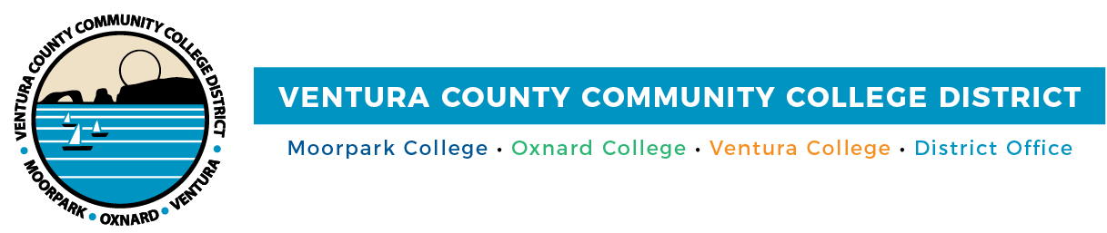

FOR IMMEDIATE RELEASE

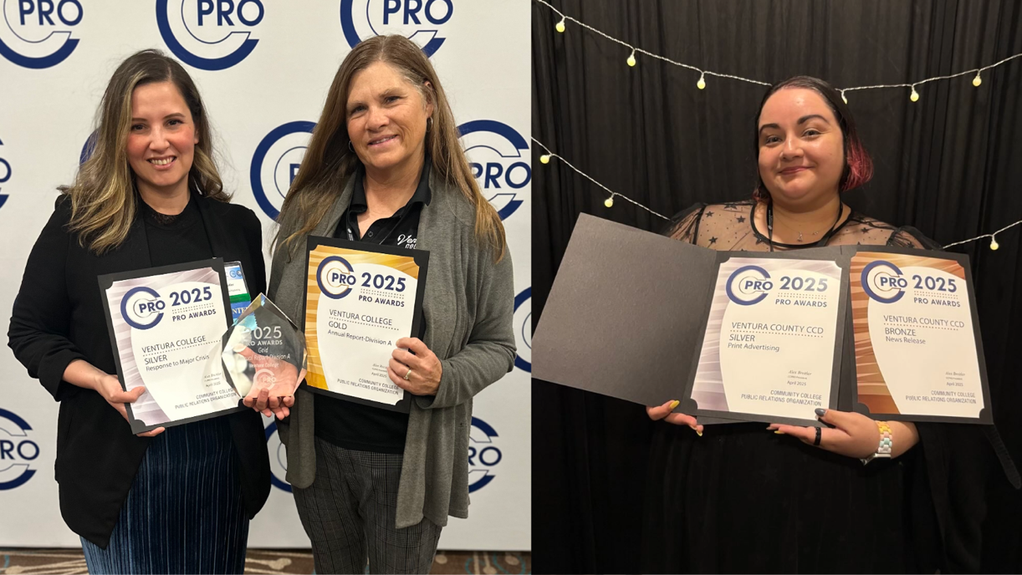

VCCCD Marketing Teams Honored in Public Relations Awards Ceremony
DAC and Ventura College teams took home four wins

Camarillo, Calif. (April 25, 2025) — In a year where authentic storytelling and cultural relevance stood out as creative imperatives, the marketing teams at Ventura College and the District Administrative Center (DAC) rose to the occasion. At the 2025 Community College Public Relations Organization (CCPRO) Pro Awards, both teams were honored for campaigns that didn’t just communicate—but connected.
CCPRO is a statewide professional organization that supports marketing, public relations, and communications professionals at California’s community colleges. The group provides opportunities for professional development, resource sharing, and collaboration across districts. Its annual Pro Awards recognize outstanding work in areas like media relations, advertising, design, and crisis communication.
From highlighting the value of hiring our graduates in high-demand industries to celebrating LGBTQIA+ students at Lavender Graduation, the recognized submissions exemplified the district’s commitment to equity, community connection, and opportunity.
The district was recognized with the following awards at CCPRO’s annual conference in April:
- Gold: annual report (Ventura College). Ventura College’s 2024 Annual Report “Making Dreams Come True” showcased student success, institutional progress, and community impact through narrative storytelling and visual design.
- Bronze: news release (DAC). Honored for message clarity, depth, and emotional impact, “VCCCD Celebrates LGBTQIA+ Students at Second Annual Lavender Graduation” highlighted the district’s commitment to belonging and visibility for LGBTQIA+ students.
- Silver: print advertising (DAC). Designed for the Pacific Coast Business Times, the Educating Your Workforce print ad promoted open registration with a bold, equity-centered message aimed at regional employers and working adults.
- Silver: response to crisis (Ventura College). Recognized for strategic clarity and real-time responsiveness during the atmospheric river storms that impacted Southern California.
“These awards reflect more than just strong communications—they showcase how our teams are elevating the everyday excellence of our colleges,” said Chancellor Rick MacLennan. “From crisis response to student celebrations, they’re helping tell the stories that define who we are. I’m incredibly proud of the creativity and dedication that our districtwide team brings to this work.”
The Outreach and Marketing teams at Ventura College and the District Administrative Center work collaboratively while serving their respective organizations. The Ventura College team includes Director Vanessa Stotler and Marketing, Communications, and Web Design Coordinator Janeene Nagaoka, while the District-level team is comprised of Coordinators Allie Frazier and Diana Martin. Together, they support aligned goals through distinct institutional roles.

The district’s award-winning work underscores its commitment to accessible, impactful communication that reflects the diverse communities it serves. To learn more about VCCCD’s colleges and programs, visit vcccd.edu.

About Ventura County Community College District
The Ventura County Community College District is a member of the 116-campus California Community College system and serves approximately 30,000 students annually. The District's three colleges—Moorpark, Oxnard and Ventura—offer programs in general education for degrees and certificates, transfer to four-year colleges and universities, career technical education and provide opportunities to engage in co-curricular campus activities. For more information, visit vcccd.edu.

Media Contact:
Outreach and Marketing
Ventura County Community College District
communications@vcccd.edu

