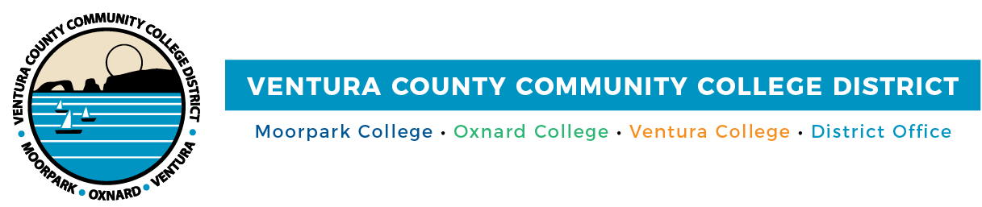

**FOR IMMEDIATE RELEASE**

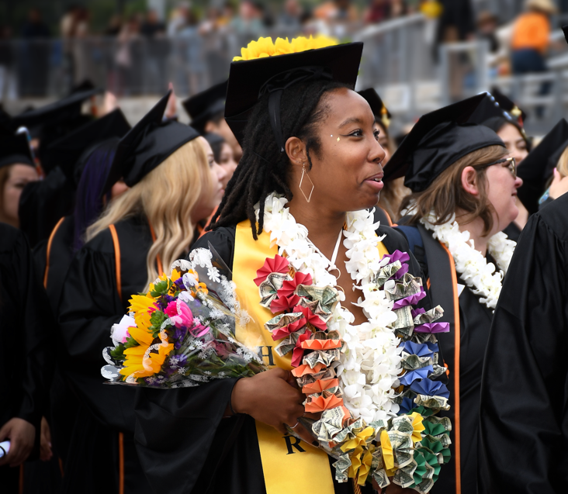

**Community Colleges of Ventura County Celebrate Class of 2024**

*Commencement ceremonies honor students at Moorpark, Oxnard, and Ventura colleges*

**Camarillo, Calif.** (May 23, 2024) — Amid triumphant applause and proud cheers , the Community Colleges of Ventura County honored 5,515 graduates this week. The 2024 Commencement ceremonies were held at Oxnard College on May 16 and Moorpark and Ventura colleges on May 17, celebrating all the hard work and determination shown by the graduating class of 2024.

This year, the class of 2024 proudly earned a total of 8,147 associate degrees and 4,358 certificates. Reflecting the colleges’ emphasis on comprehensive education and versatility, many of this year’s students are graduating with multiple degrees and certificates, reflecting their diverse set of skills and knowledge as they embark on their professional journeys or continue their studies at four-year institutions.

“As we gather to celebrate the accomplishments of this year’s graduates, I am immensely proud of each and every student,” said Chancellor Rick MacLennan. “You have overcome countless challenges, juggled responsibilities, and demonstrated unwavering commitment to your studies. Your determination and resilience have brought you to this pivotal moment, where you stand on the threshold of a new chapter in your lives. I offer my heartfelt congratulations to each and every one of our graduates. Go forth, make your mark on the world! Your success is our success!”

“I am proud when I hear community members tell me their child, or their grandchild, or they themselves graduated from one of our three excellent community colleges and this experience prepared them for their personal and professional successes,” said Bernardo M. Perez, Board Chair. “Our graduates will now be the face of success in the fields of nursing, dental hygiene, biotechnology, public safety, and many other fields of endeavor. I wish them all continued success.”

After the ceremonies, the college presidents reflected on the promising paths that lie ahead for their graduates:

“Today we honor the individual achievements of our graduates and also the collective growth and accomplishments of our community,” said Julius Sokenu, president of Moorpark College. “It is this spirit of shared progress that serves as the foundation of the Community College mission—to bring the promise and opportunity of education to anyone with a hunger for knowledge and the dream of a brighter future. These values are now an indelible part of our graduates’ life story as they are all living proof of the progress and achievement that blooms when these principles are actualized in our community.”

“We are proud of the achievements of the class of 2024, many of whom have overcome significant personal and economic challenges to arrive at this moment of celebration,” shared Dr. Oscar Cobian, interim president of Oxnard College. “Each of our graduates has a unique and inspiring story of success. We are grateful to have played a part in their journey to new careers and four-year universities across the nation.”

"This graduation holds a special place in my heart, as it marks my final graduation as president,” said Kim Hoffmans, president of Ventura College. “Over my five-year tenure, I have been profoundly inspired by our graduates and their dedication to uplifting their communities through education. I encourage our 2024 graduates to embrace their next chapter fearlessly and to forge ahead with unwavering determination. Congratulations, Class of 2024!"

**About Ventura County Community College District**

*The Ventura County Community College District is a member of the 116-campus California Community College system and serves approximately 30,000 students annually. The District's three colleges—Moorpark, Oxnard and Ventura—offer programs in general education for degrees and certificates, transfer to four-year colleges and universities, career technical education and provide opportunities to engage in co-curricular campus activities. For more information, visit* [*vcccd.edu*](http://www.vcccd.edu)*.*

**Media Contact:**

Outreach and Marketing

Ventura County Community College District

[communications@vcccd.edu](mailto:communications@vcccd.edu)