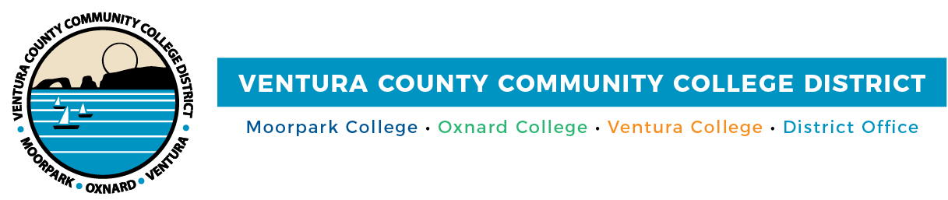

FOR IMMEDIATE RELEASE

VCCCD Internship Opportunity to Provide Beautiful Music for All
Two Moorpark College students will write custom music for the District and its colleges

Camarillo, Calif. (October 30, 2020)—The Ventura County Community College District has created a unique internship opportunity for two Moorpark College aspiring music professionals. Students Dan Damore and Alex Fortunato will create original music scores for the District’s marketing projects, including music to be played prior to Board of Trustees meetings and during breaks. Scores will also be written for Moorpark, Oxnard and Ventura colleges and Ventura College East Campus.

“Our faculty work to provide our students with opportunities that not only enhance their career preparedness, but allow them to gain real-world experience,” said Moorpark College Interim President Julius Sokenu.

“The board is fully supportive of giving our students every opportunity to practice their craft,” added Chair Bernardo M. Perez. “We look forward to hearing the music that Dan and Alex create.”

Moorpark College music professors Nathan Bowen and Brandon Elliott were instrumental in establishing the internship, which runs through the end of the fall semester with Fortunato and Damore. Plans are to continue the internship for the spring 2021 semester.

Damore is an aspiring composer for film, television and video games. He received his bachelor’s degree in 2020 in music with an emphasis in instrumental education from California State University, Fullerton, School of Music. Damore was a member of Phi Mu Alpha Sinfonia, a national music fraternity, and the Oregon Crusaders Drum and Bugle Corps. He also worked as a visual technician with the Anaheim High School marching band. To expand his composition skills for film and television, Damore is pursuing a certificate of achievement in music technology at Moorpark College.

Fortunato, a third-year Moorpark College honors student, is an up-and-coming expert in the world of music. In 2019, he received leadership training from Vanguard Music & Performing Arts, a selective and prestigious youth arts program. For the 2019 Drum Corps International season, Fortunato served as the drum sergeant/section leader of the Vanguard Cadets Drum & Bugle Corps, which involved collaboration with professional and student artists from the U.S., Japan and the U.K. He has worked as a percussion instructor, produced multiple original works for companies, and was a Drum Corps International Open Class World Champion, winning a gold medal and the High Percussion Award.

“In the music business, having finished content is how one gets the next gig. Your demo reel tells a lot about who you are and what you've been doing. Additionally, knowing how to work in collaborative creative projects is perhaps just as important, and this internship will be providing the opportunity for Dan and Alex to develop in all aspects of the profession,” said Bowen, who earned his doctorate in music composition from the Graduate Center at the City University of New York. His dissertation on mobile phone music received the Barry Brook Dissertation Award and he has collected invitations to conduct research at the Institut de Recherche et Coordination Acoustique/Musique with the Real Time Interactions Team in Paris and Goldsmiths in London.

“Our faculty members ensure that our students have the best preparation possible to enter the multi-billion-dollar music industry with a competitive advantage,” said Elliott. “In partnership with the District, this new internship opportunity opens up a world of new possibilities for our students, program and college.”

Elliott is an associate professor of music; director of choral and vocal activities; applied music coordinator; and arts, media, and entertainment success team faculty lead. Under his direction, Moorpark College’s choirs have performed around the world, including St. Peter's Basilica at the Vatican City, and cities in Spain and Central Europe, along with San Francisco and San Diego.

For information about the Moorpark College music program, visit https://www.moorparkcollege.edu/departments/academic/music.

About Ventura County Community College District

The Ventura County Community College District is a member of the 116-campus California Community College system and serves approximately 31,000 students annually. The District's three colleges--Moorpark, Oxnard, and Ventura--offer programs in general education for degrees and certificates, transfer to four-year colleges and universities, career technical education, and provide opportunities to engage in co-curricular campus activities. For more information, please visit vcccd.edu.

