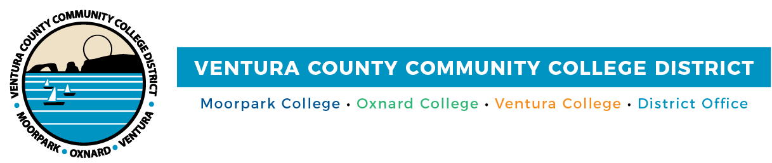

FOR IMMEDIATE RELEASE

VCCCD Supports Undocumented Students with Action Week
Week focuses on advocacy and providing support services for undocumented students

Camarillo, Calif. (October 14, 2020)—Ventura County Community College District joins California Community Colleges (CCC) and its partners across the state for Undocumented Student Action Week, October 19-23, to advocate and provide support services for undocumented students in California. This year’s action week, while virtual, serves as an opportunity to highlight the challenges undocumented students face in today’s political climate and amid COVID-19. The week serves as a vehicle to advocate to Congress about the financial and moral actions needed to ensure the safety of undocumented students.
Undocumented Student Action Week is supported statewide by CCC, the Foundation for California Community Colleges, the Community College League of California, the Academic Senate for California Community Colleges, the Student Senate for California Community Colleges, California Student Aid Commission, Immigrants Rising and the California Undocumented Higher Education Coalition.
As the nation’s largest post-secondary education system serving the largest number of undocumented students within the state, CCC is committed to serving all students, regardless of immigration status. The Dreamers Project Report discusses the state of CCC undocumented students, incorporating findings from a landscape analysis to identify shared challenges in serving this vulnerable population. Recommendations about how to better serve undocumented students, paired with promising practices already underway, are provided for implementation at the individual, group and institutional levels for systemic change that benefits California. When undocumented students can pursue an education and careers, they can create new, brighter futures for themselves, their families and their communities.
“We want to reassure our approximately 31,000 students attending Moorpark, Oxnard and Ventura colleges that our campuses are safe and welcoming spaces for people of all backgrounds to learn and grow,” said Board Chair Bernardo M. Perez.
“Many students and community members do not realize the challenges undocumented students face when pursuing a college degree,” added Chancellor Greg Gillespie. “The resources available on our campuses ensure that our undocumented students have faculty and staff who can help them overcome these challenges. The resources available through Undocumented Student Action Week further demonstrate our commitment and support for students and the community.”
This year, all VCCCD campuses--Oxnard, Moorpark, Ventura and Ventura’s East Campus--will partner to provide a powerful and impactful series of events that will provide our students, their families and our community valuable information and resources. A sampling of events includes a three-part series entitled UndocuHustle Workshop - Panel (to help students learn about entrepreneurship), Know Your Rights in Partnership with the United Farm Workers Foundation, Medi-Cal and Covered California Enrollment Information for Undocumented Families and Potential Immigration Relief Options for Undocumented Individuals. For a complete list of Undocumented Student Action Week events, visit vcccd.edu/students/undocually. These online events are free and open to students, their families, allies, faculty, staff and the community.
About Ventura County Community College District
The Ventura County Community College District is a member of the 116-campus California Community College system and serves approximately 31,000 students annually. The District's three colleges--Moorpark, Oxnard and Ventura--offer programs in general education for degrees and certificates, transfer to four-year colleges and universities, career technical education and provide opportunities to engage in co-curricular campus activities. For more information, visit vcccd.edu.
###
Media Contact:
Patti Blair
Director, Public Affairs and Marketing
Ventura County Community College District
communications@vcccd.edu

